Individual Assignment

Darshan Kalpeshbhai Prajapati

Id:112908215

Email: [dkprajapati2@myseneca.ca](mailto:dkprajapati2@myseneca.ca)

Class diagram

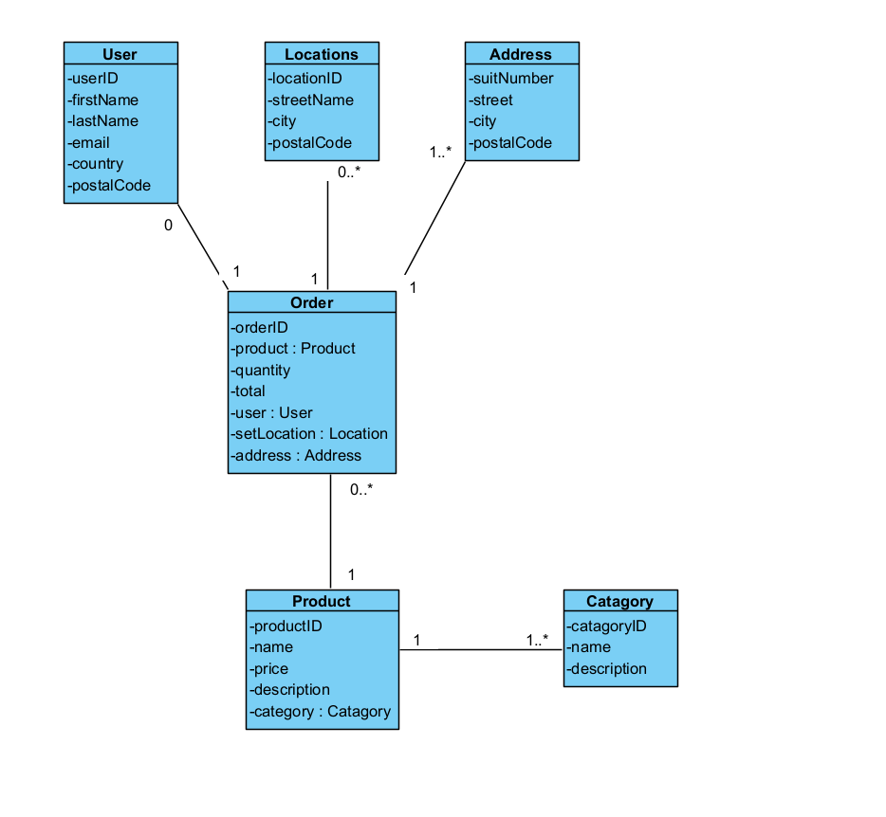

Signup process

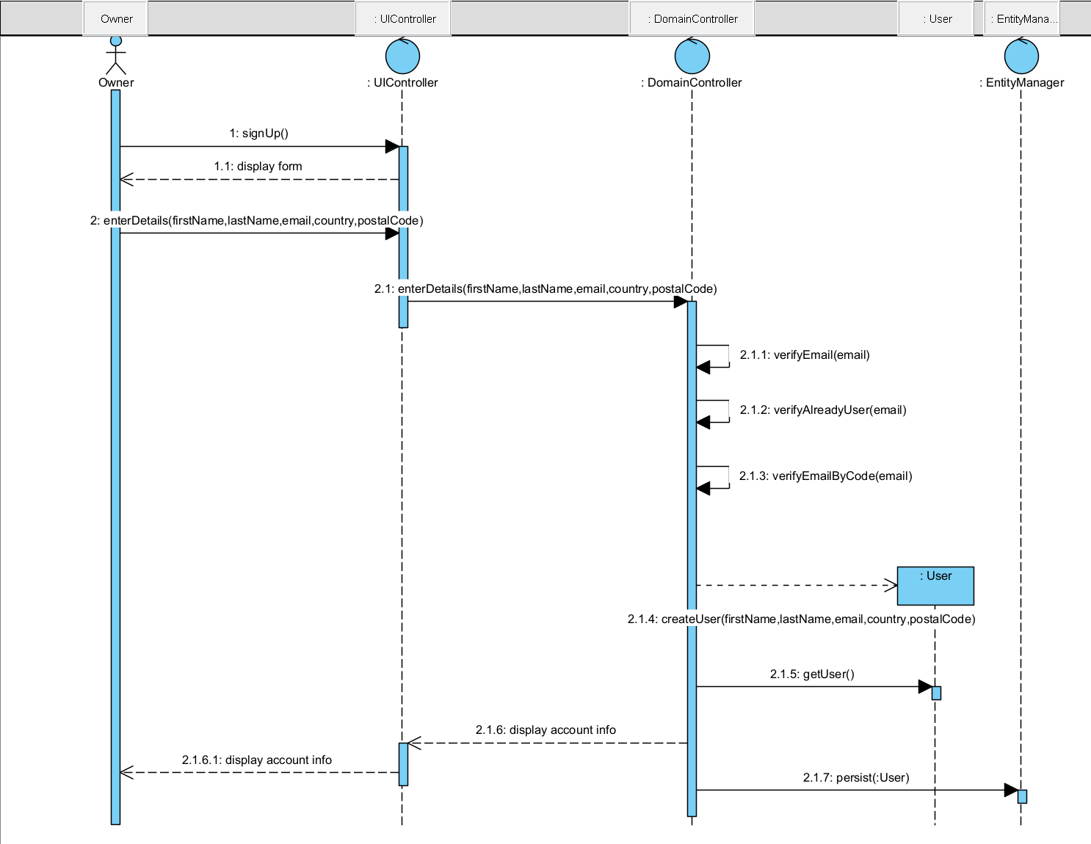

Create order process

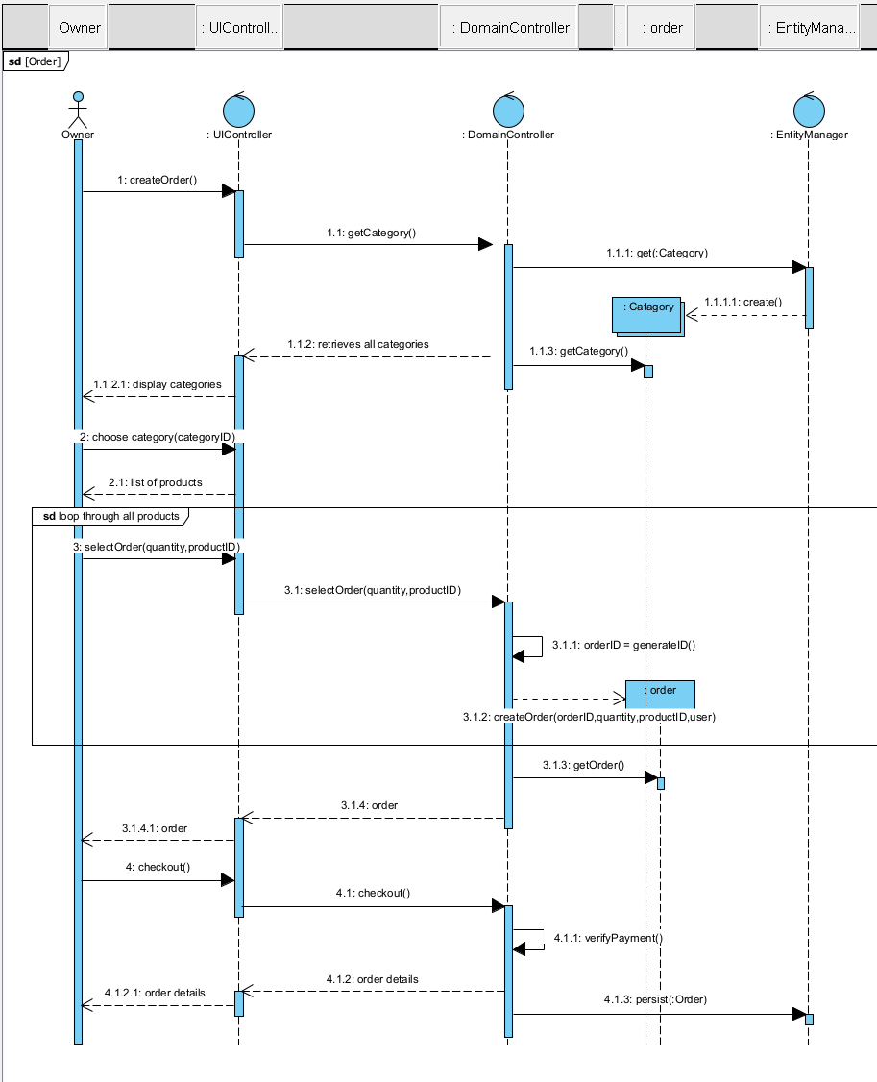

Reflaction:

Why I Chose this website?

I chose Lowes.ca for its complexity and diverse features, offering rich insights into real-world e-commerce development. Its user-friendly design, performance optimization, security measures, and relevance to my interest in home improvement make it an ideal subject for understanding modern web practices and enhancing my web development skills.

You can signup by clicking signup button on top right corner which is very easy for anyone.

Ordering anything is also simple just by clicking add to cart option and it also gives you option to add promocodes through which discounts are processed.

Checkout is also easy and it also includes section to get a subscription.

